**PATUAKHALI SCIENCE AND TECHNOLOGY UNIVERSITY**

Course Code: C

IT

-

11

2



**SUBMITTED TO:**

MD Mahbubur Rahman Sir

**Department of Computer Science And Communication**

**Engineering**

**Faculty of Computer Science And Engineering**

**SUBMITTED BY:**

Name: MD Noushad Bhuiyan

ID: 20210238, Registration No: 10165

Faculty of Computer Science and Engineering

**Date of submission: 22-3-2023**

1. **2D Array Scanning value**

#include<stdio.h>

int main()

{

int n1,n2,a[100][100],i,j;

printf("Enter raw number: ");

scanf("%d",&n1);

printf("Enter colom number: ");

scanf("%d",&n2);

for(i=0;i<n1;i++)

{

for(j=0;j<n2;j++)

{

scanf("%d",&a[i][j]);

}

}

for(i=0;i<n1;i++)

{

for(j=0;j<n2;j++)

{

printf("%d ",a[i][j]);

}

printf("\n");

}

}

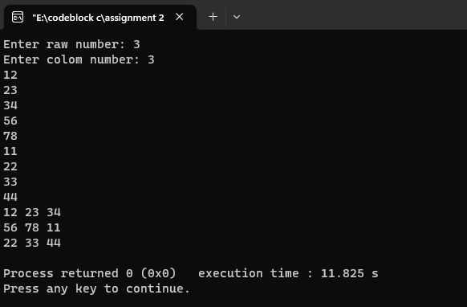

1. **Add another string without using strcat function**

#include<stdio.h>

int main()

{

char len=0,a[1000],b[1000],i,j;

printf("Enter String A: ");

gets(a);

printf("Enter String B: ");

gets(b);

i=0;

j=0;

while(a[i]!='\0')

{

len++;

i++;

}

while(b[j]!=0)

{

a[len+j]=b[j];

j++;

}

printf("%s",a);

}

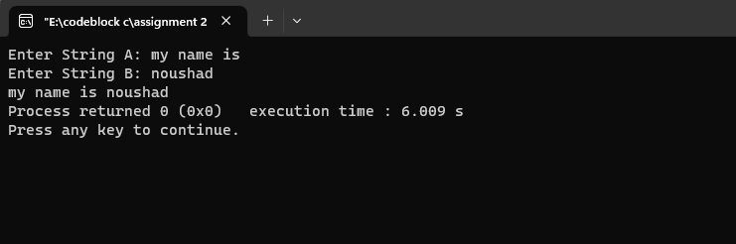

1. **Armstrong Number**

#include<stdio.h>

int main()

{

int n,num,temp=0,r;

printf("Enter a number: ");

scanf("%d",&n);

num=n;

while(num!=0)

{

r=num%10;

temp=temp+(r*r*r);

num=num/10;

}

if(temp==n)

printf("The number is a armstrong number");

else

printf("Not a armstrong number");

return 0;

}

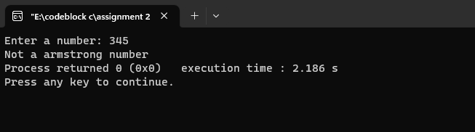

1. **Array Fibonacci number**

#include<stdio.h>

int main()

{

int sum=0,i,n,a[100];

printf("Enter n: ");

scanf("%d",&n);

a[0]=0;

a[1]=1;

printf("%d\n",a[0]);

printf("%d\n",a[1]);

for(i=2;i<n;i++)

{

a[i]=a[i-1]+a[i-2];

printf("%d\n",a[i]);

}

}

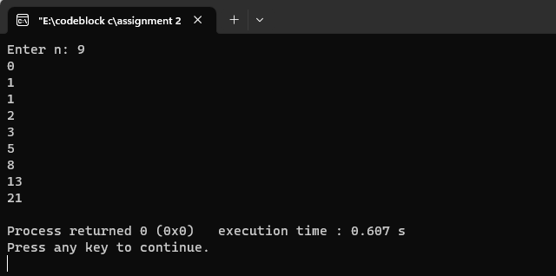

1. **Array matrix Sub**

#include<stdio.h>

int main()

{

int i,j,n1,n2,a[100][100],b[100][100],c[100][100];

printf("Enter the raw number: ");

scanf("%d",&n1);

printf("Enter the columb number: ");

scanf("%d",&n2);

for(i=0;i<n1;i++)

{

for(j=0;j<n2;j++)

{

scanf("%d",&a[i][j]);

}

}

printf("Matrix A:\n");

for(i=0;i<n1;i++)

{

for(j=0;j<n2;j++)

{printf("A[%d][%d] = %d ",i,j,a[i][j]);

}

printf("\n");

}

//end of matrix a

for(i=0;i<n1;i++)

{

for(j=0;j<n2;j++)

{

scanf("%d",&b[i][j]);

}

}

printf("Matrix B:\n");

for(i=0;i<n1;i++)

{

for(j=0;j<n2;j++)

{

printf("B[%d][%d] = %d ",i,j,a[i][j]);

}

printf("\n");

}

//end of matrix b;

printf("\n\nMatrix A - Matrix B = \n");

for(i=0;i<n1;i++)

{

for(j=0;j<n2;j++)

{

c[i][j]= a[i][j]-b[i][j];

printf("[%d][%d] = %d ",i,j,c[i][j]);

}

printf("\n");

}

}

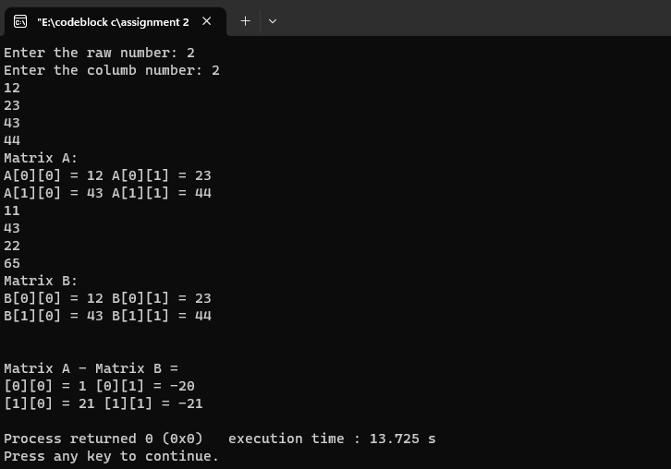

1. **Array matrix Sum**

#include<stdio.h>

int main()

{

int i,j,n1,n2,a[100][100],b[100][100],c[100][100];

printf("Enter the raw number: ");

scanf("%d",&n1);

printf("Enter the columb number: ");

scanf("%d",&n2);

for(i=0;i<n1;i++)

{

for(j=0;j<n2;j++)

{

scanf("%d",&a[i][j]);

}

}

printf("Matrix A:\n");

for(i=0;i<n1;i++)

{

for(j=0;j<n2;j++)

{printf("A[%d][%d] = %d ",i,j,a[i][j]);

}

printf("\n");

}

//end of matrix a

for(i=0;i<n1;i++)

{

for(j=0;j<n2;j++)

{

scanf("%d",&b[i][j]);

}

}

printf("Matrix B:\n");

for(i=0;i<n1;i++)

{

for(j=0;j<n2;j++)

{

printf("B[%d][%d] = %d ",i,j,a[i][j]);

}

printf("\n");

}

//end of matrix b;

printf("\n\nMatrix A - Matrix B = \n");

for(i=0;i<n1;i++)

{

for(j=0;j<n2;j++)

{

c[i][j]= a[i][j]+b[i][j];

printf("[%d][%d] = %d ",i,j,c[i][j]);

}

printf("\n");

}

}

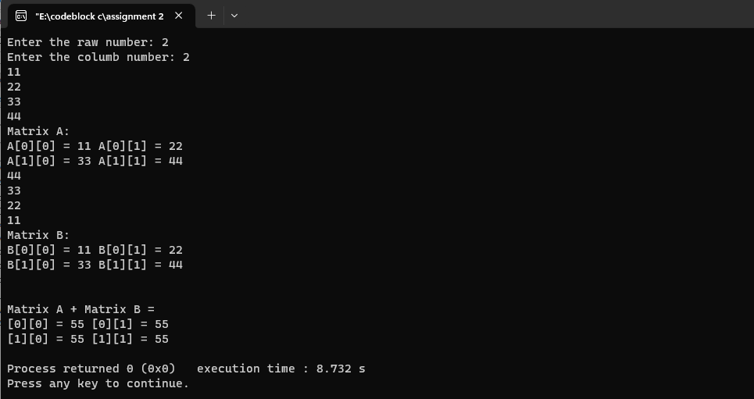

1. **Array matrix sum of Diagonal digits**

#include<stdio.h>

int main()

//The sum of diagonal elements

{

int n1,n2,i,j,a[100][100],sum=0;

printf("Enter raw number : ");

scanf("%d",&n1);

printf("Enter columb number : ");

scanf("%d",&n2);

for(i=0;i<n1;i++)

{

for(j=0;j<n2;j++)

{

scanf("%d",&a[i][j]);

}

}

printf("Matrix A:\n");

for(i=0;i<n1;i++)

{

for(j=0;j<n2;j++)

{

printf("A[%d][%d] = %d ",i,j,a[i][j]);

}

printf("\n");

}

for(i=0;i<n1;i++)

{

for(j=0;j<n2;j++)

{

if(i==j )

{

sum=sum+a[i][j];

}

}

}

printf("The sum of diagonal elements are: %d",sum);

}

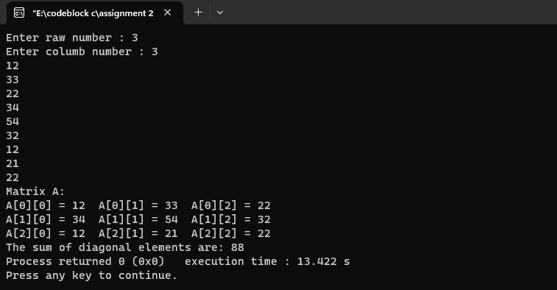

1. **Array matrix sum of lower triangle digits of matrix**

#include<stdio.h>

int main()

//The sum of lower Triangle digits

{

int n1,n2,i,j,a[100][100],sum=0;

printf("Enter raw number : ");

scanf("%d",&n1);

printf("Enter columb number : ");

scanf("%d",&n2);

for(i=0;i<n1;i++)

{

for(j=0;j<n2;j++)

{

scanf("%d",&a[i][j]);

}

}

printf("Matrix A:\n");

for(i=0;i<n1;i++)

{

for(j=0;j<n2;j++)

{

printf("A[%d][%d] = %d ",i,j,a[i][j]);

}

printf("\n");

}

for(i=0;i<n1;i++)

{

for(j=0;j<n2;j++)

{

if(i==j || i>j)

{

sum=sum+a[i][j];

}

}

}

printf("The sum of lower Triangle elements are: %d",sum);

}

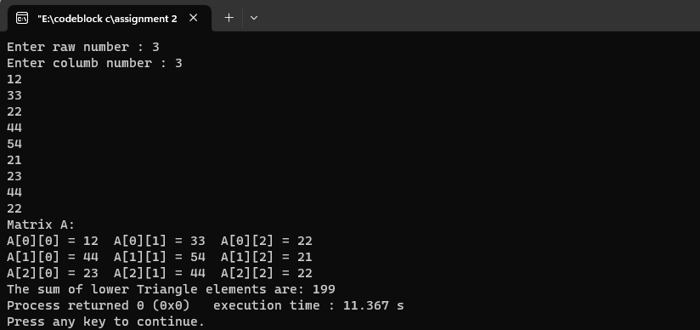

1. **Array matrix sum of upper Triangle digits**

#include<stdio.h>

int main()

//The sum of Upper triangle digits

{

int n1,n2,i,j,a[100][100],sum=0;

printf("Enter raw number : ");

scanf("%d",&n1);

printf("Enter columb number : ");

scanf("%d",&n2);

for(i=0;i<n1;i++)

{

for(j=0;j<n2;j++)

{

scanf("%d",&a[i][j]);

}

}

printf("Matrix A:\n");

for(i=0;i<n1;i++)

{

for(j=0;j<n2;j++)

{

printf("A[%d][%d] = %d ",i,j,a[i][j]);

}

printf("\n");

}

for(i=0;i<n1;i++)

{

for(j=0;j<n2;j++)

{

if(i==j || i<j)

{

sum=sum+a[i][j];

}

}

}

printf("The sum of Upper triangle elements are: %d",sum);

}

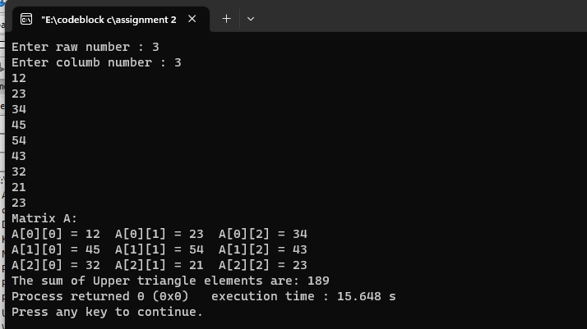

1. **Array minimum number**

#include<stdio.h>

int main()

{

int n,a[5],i;

printf("Enter number of n: ");

scanf("%d",&n);

for(i=0;i<n;i++)

{

printf("Enter numbers: ");

scanf("%d",&a[i]);

}

int min= a[0];

for(i=1;i<n;i++)

{

if(min>a[i])

{

min=a[i];

}

}

printf("Minimum Number is : %d",min);

}

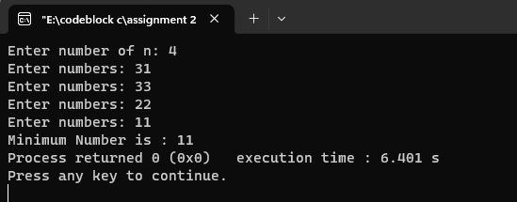

1. **Array max value with using function**

#include<stdio.h>

int maximum(int x[])

{

int i,max;

max=x[0];

for(i=0;i<5;i++)

{

if(max<x[i])

max=x[i];

}

return max;

}

int main()

{

int a[]={20,30,40,50,60};

int maxi = maximum(a);

printf("the max value is %d",maxi);

}

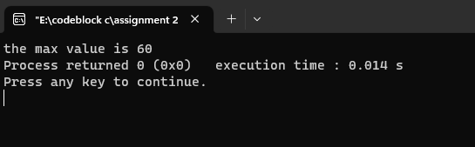

1. **Ascending to descending Form**

#include<stdio.h>

int main()

{ int i,j;

printf("inpur a pair of numbers(for example 10,2 : 2,10)\n");

printf("Enter pair 1st number: ");

scanf("%d",&i);

printf("Enter pair 2nd number: ");

scanf("%d",&j);

if(i>j)

{printf("The pair is in descending order !");}

else

{printf("The pair is in ascending order !");}

}

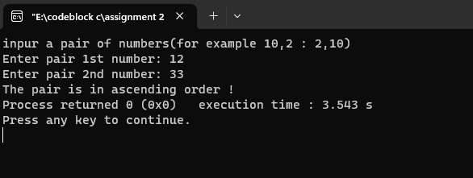

1. **ASCII Value to Integer number**

#include<stdio.h>

int main()

{ char n;

printf("Enter an character : ");

scanf("%c",&n);

printf("The ASCII value of the character is: %d",n);

return 0;

}

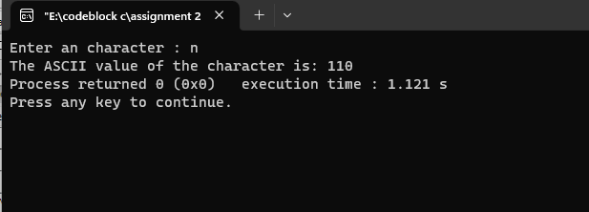

1. **Calculator (Sum, Sub, Multiplication, Division)**

#include<stdio.h>

int main()

{

float sum,sub,mul,div;

int a,b,n;

printf("Main menu:\n1.SUM\n2.SUB\n3.MUlTIPLICATION\n4.DIVISION\nEnter your choice: ");

scanf("%d",&n);

switch(n)

{

case 1:

{printf("Enter 1st value:");

scanf("%d",&a);

printf("Enter 1st value:");

scanf("%d",&b);

sum=a+b;

printf("Sum is: %0.2f",sum);}

break;

case 2:

{printf("Enter 1st value:");

scanf("%d",&a);

printf("Enter 1st value:");

scanf("%d",&b);

sub=a-b;

printf("Sub is: %0.2f",sub);}

break;

case 3:

{printf("Enter 1st value:");

scanf("%d",&a);

printf("Enter 1st value:");

scanf("%d",&b);

mul=a*b;

printf("Multiplication is: %0.2f",mul);}

break;

case 4:

{printf("Enter 1st value:");

scanf("%d",&a);

printf("Enter 1st value:");

scanf("%d",&b);

div=a/b;

printf("Division is: %0.2f",div);}

break;

}

}

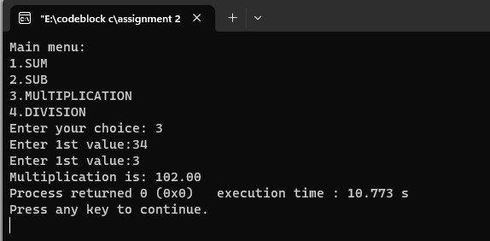

1. **Capital and small letter recognition**

#include<stdio.h>

int main()

{

char ch;

printf("enter a letter:");

scanf("%c",&ch);

if(ch>='a'&&ch<='z')

printf("this is a small letter");

else if(ch>='A'&&ch<='Z')

printf("this is a capital letter");

return 0;

}

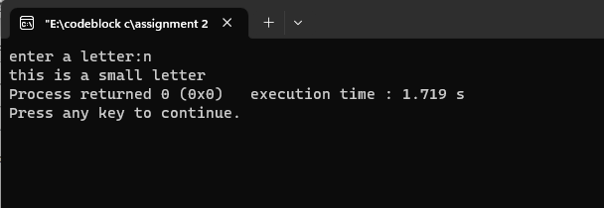

1. **Celsius to fahrenheight**

#include<stdio.h>

int main()

{

float c,f;

printf("Enter Celcius degree: ");

scanf("%f",&c);

f=(((9*c)/5)+32);

printf("Fareignheight Degree is: %0.2f",f);

}

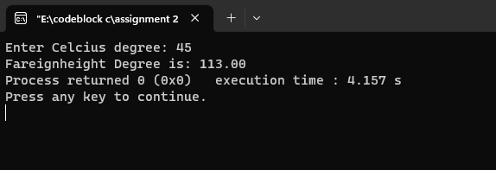

1. **Celsius to kelvin**

#include<stdio.h>

int main()

{

float c,k;

printf("Enter Celcius degree: ");

scanf("%f",&c);

k=(c+273);

printf("Calvin temperature is: %0.2f",k);

}

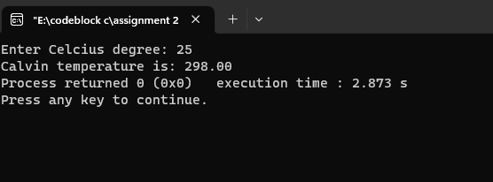

1. **Counting the number of a digit in an integer.**

#include<stdio.h>

int main()

{

int n,r,sum=0;

printf("enter an integer: ");

scanf("%d",&n);

while(n!=0)

{

n=n/10;

sum++;

}

printf("The number of digits are: %d",sum);

return 0;

}

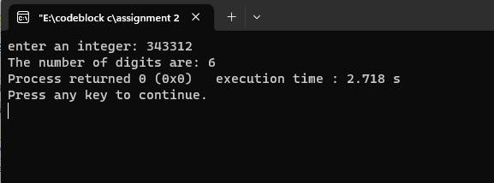

1. **Decimal to hexadecimal**

#include<stdio.h>

int main()

{

int n;

printf("Enter the decimal number: ");

scanf("%d",&n);

printf("The hexadecimal number is: %x",n);

return 0;

}

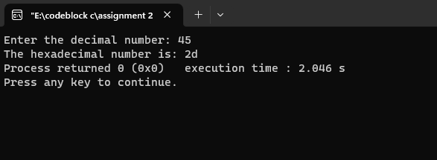

1. **Decimal to octal**

#include<stdio.h>

int main()

{

int n;

printf("Enter the decimal number: ");

scanf("%d",&n);

printf("The octal number is: %o",n);

return 0;

}

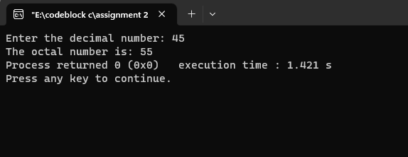

1. **Even or Odd number**

#include<stdio.h>

int main()

{ int num;

printf("Enter an ingeger: ");

scanf("%d",&num);

if(num%2==0)

printf("Even");

else if(num!=0)

printf("odd");

else

printf("the number is 0");

return 0;

}

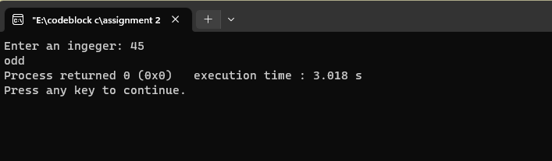

1. **Expotential Function**

#include<stdio.h>

int main()

{

double result,x;

printf("Enter exp value: ");

scanf("%lf",&x);

result=exp(x);

printf("exp(%0.1lf)= %0.2lf",x,result);

return 0;

}

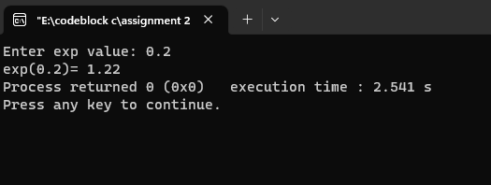

1. **Factorial of a digit**

#include<stdio.h>

int main()

{

int n,i,fact=1;

printf("Enter any positive number: ");

scanf("%d",&n);

for(i=1;i<=n;i++)

{

fact=fact*i;

}

printf("factorial of %lf is = %d",n,fact);

}

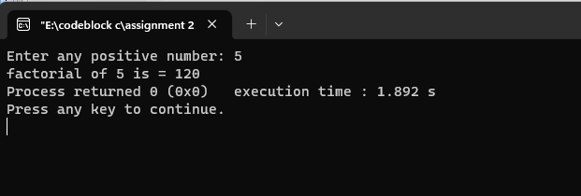

1. **Fahrenheight to celsius**

#include<stdio.h>

int main()

{

float c,f;

printf("Enter Faregnheight degree: ");

scanf("%f",&f);

c=(((f-32)*5)/9);

printf("Celcius Degree is: %0.2f",c);

}

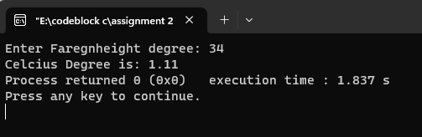

1. **Fibonacci number**

#include<stdio.h>

int main()

{ //fibonacci number

int n,i,num1=0,num2=1,fib;

printf("Enter n: ");

scanf("%d",&n);

printf("%d\n",num1);

printf("%d\n",num2);

for(i=0;i<=n-3;i++)

{

fib=num1+num2;

num1=num2;

num2=fib;

printf("%d\n",fib);

}

}

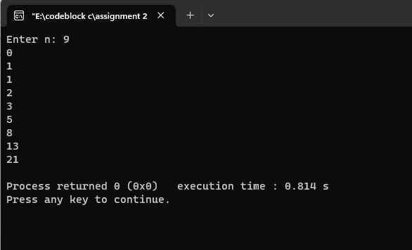

1. **Find the number position**

#include<stdio.h>

int main()

{

int position=-1,i,n,a[100],value,pos;

printf("Enter n: ");

scanf("%d",&n);

for(i=0;i<n;i++)

{

printf("Enter numbers: ");

scanf("%d",&a[i]);

}

printf("Enter the number: ");

scanf("%d",&value);

for(i=0;i<n;i++){

if(value==a[i])

{

pos=i+1;

break;

}

}

if(position==-1)

printf("not found");

else

{

printf("The position of this number is %d",pos);

}

}

1. **Area of a triangle using function**

#include<stdio.h>

double areatriangle(double a,double b);

double main()

{

double height,weight;

printf("Enter height: ");

scanf("%lf",&height);

printf("Enter weight: ");

scanf("%lf",&weight);

double area= areatriangle(height,weight);

printf("The area of the triangle is : %0.2lf",area);

}

(

return 0.5*a*b ;

)

1. **Power value using function**

#include<stdio.h>

int main()

{

int a,b;

printf("Enter X: ");

scanf("%d",&a);

printf("Enter n: ");

scanf("%d",&b);

int powervalue = value(a,b);

printf("The value is: %d",powervalue);

}

int value(int x,int n)

{

return pow(x,n);

}

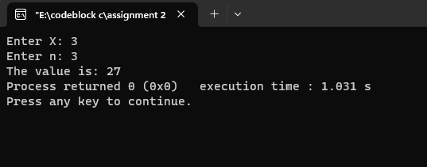

1. **String using function**

#include<stdio.h>

int main()

{

char s[100];

printf("Enter string: ");

gets(s);

int f = string(s);

printf("The number of Upper case letter is: %d",f);

}

int string(char x[])

{

int u=0,l=0,i=0,o=0;

while(x[i]!='\0')

{

if(x[i]>=65 && x[i]<=90 )

{ u++;}

else if(x[i]>=97 && x[i]<=122)

{

l++;

}

else

{

o++;

}

i++;

}

return u;

}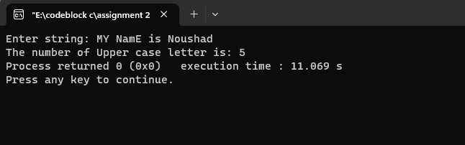

1. **Hexadecimal to decimal**

#include<stdio.h>

int main()

{

int n;

printf("Enter the hexadecimal number: ");

scanf("%x",&n);

printf("The decimal number is: %d",n);

return 0;

}

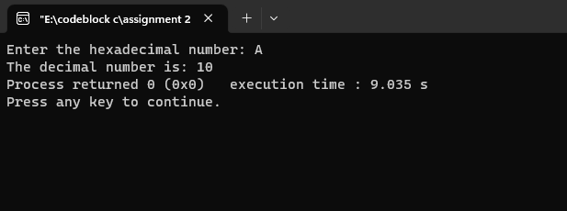

1. **Hexadecimal to octal**

#include<stdio.h>

int main()

{

int n;

printf("Enter the hexadecimal number: ");

scanf("%x",&n);

printf("The octal number is: %o",n);

return 0;

}

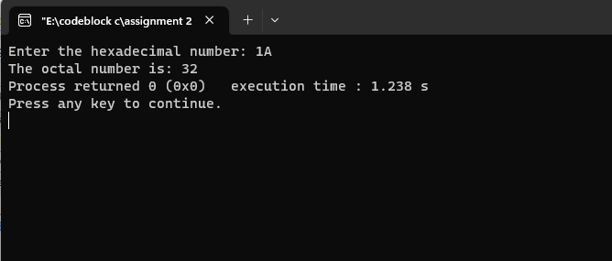

1. **Higher number and position from 5 number**

#include<stdio.h>

int main()

{

int a,b,c,d,e;

printf("Enter a: ");

scanf("%d",&a);

printf("Enter b: ");

scanf("%d",&b);

printf("Enter c: ");

scanf("%d",&c);

printf("Enter d: ");

scanf("%d",&d);

printf("Enter e: ");

scanf("%d",&e);

if(a>b&&a>c&&a>d&&a>e)

{

printf("Highest value: %d\nposition = 1",a);

}

else if(b>a&&b>c&&b>d&&b>e)

{

printf("Highest value: %d\nposition = 2",b);

}

else if(c>b&&c>a&&c>d&&c>e)

{

printf("Highest value: %d\nposition = 3",c);

}

else if(d>b&&d>c&&d>a&&d>e)

{

printf("Highest value: %d\nposition = 4",d);

}

else

{

printf("Highest value: %d\nposition = 5",e);

}

return 0;

}

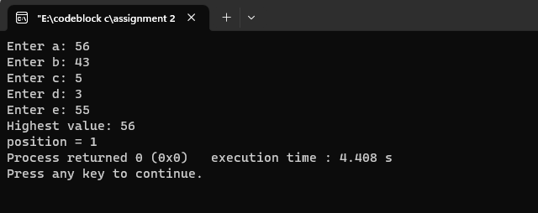

1. **Integer number to ASCII value**

#include<stdio.h>

int main()

{ char n;

printf("Enter an ASCII value: ");

scanf("%d",&n);

printf("The ASCII value of the character is: %c",n);

return 0;

}

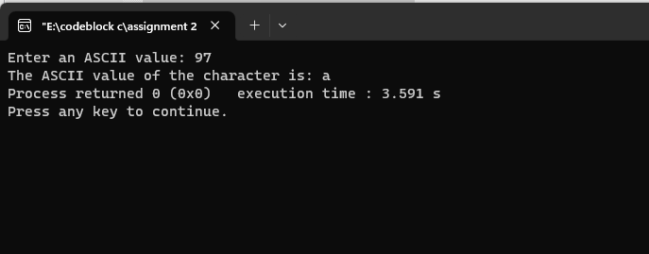

1. **Kelvin to Celsius**

#include<stdio.h>

int main()

{

float c,k;

printf("Enter kelvin temperature: ");

scanf("%f",&k);

c=(k-273));

printf("Temperature in celcius is: %0.2f",c);

return 0;

}

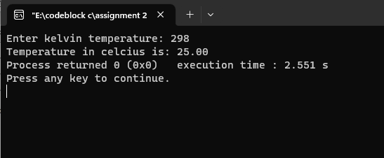

1. **LCM and GCD**

#include<stdio.h>

int main()

{

int n1,n2,rem,lcm,gcd,num1,num2;

printf("Enter 1st number: ");

scanf("%d",&num1);

printf("Enter 2nd number: ");

scanf("%d",&num2);

n1=num1;

n2=num2;

while(n2!=0)

{

rem=n1%n2;

n1=n2;

n2=rem;

}

gcd=n1;

lcm=((num1*num2)/gcd);

printf("GCD is %d\n",gcd);

printf("LCM is %d\n",lcm);

}

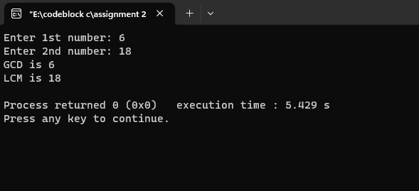

1. **Use of Log function**

#include<stdio.h>

int main()

{

double result,x;

printf("Enter log value: ");

scanf("%lf",&x);

result=log(x);

printf("%0.2lf",result);

return 0;

}

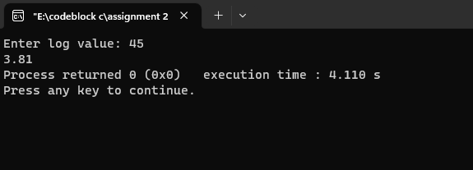

1. **Using of Log10 function**

#include<stdio.h>

int main()

{

double result,x;

printf("Enter log10 value: ");

scanf("%lf",&x);

result=log10(x);

printf("log10(%0.1lf)= %0.2lf",x,result);

return 0;

}

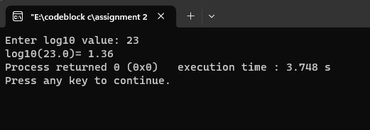

1. **Lower case letter to upper case letter without using function**

#include<stdio.h>

int main()

{

char lower;

printf("Enter a lower case letter: ");

scanf("%c",&lower);

printf("The upper case letter is: %c",lower-32);

}

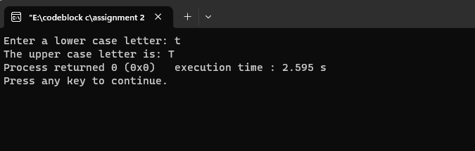

1. **Lower case letter to upper case letter using library function**

#include<stdio.h>

int main()

{

char lower,upper;

printf("Enter a lower case letter: ");

scanf("%c",&lower);

upper = toupper(lower);

printf("The upper case letter is: %c",upper);

}

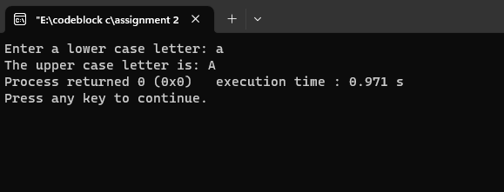

1. **Maximum number from array**

#include<stdio.h>

int main()

{

int n,a[100],i;

printf("Enter number of n: ");

scanf("%d",&n);

for(i=0;i<n;i++)

{

printf("Enter numbers: ");

scanf("%d",&a[i]);

}

int max= a[0];

for(i=1;i<n;i++)

{

if(max<a[i])

{

max=a[i];

}

}

printf("Maximum Number is : %d",max);

}

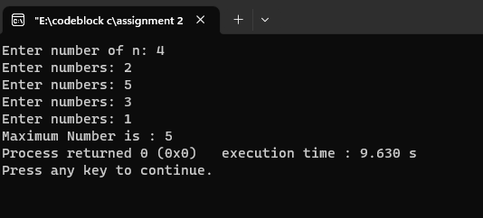

1. **Menu based temperature converter**

#include<stdio.h>

int main()

int choice;

float c,f;

printf("Temperature converter manu:\n1.Fahrenheit To Celsius.\n2.Celsius To Fahrenheit.\nEnter Your choice: ");

scanf("%d",&choice);

switch(choice)

{

case 1:

{

printf("Enter Faregnheight degree: ");

scanf("%f",&f);

c=(((f-32)*5)/9);

printf("Celcius Degree is: %0.2f",c);

}

break;

case 2:

{

printf("Enter Celcius degree: ");

scanf("%f",&c);

f=(((9*c)/5)+32);

printf("Fareignheight Degree is: %0.2f",f);

}

break;

}

}

1. **Multiplication table**

#include<stdio.h>

int main()

{

int n,i;

printf("Enter number: ");

scanf("%d",&n);

for(i=1;i<=10;i++)

{

printf("%d * %d = %d",n,i,n*i);

printf("\n");

}

}

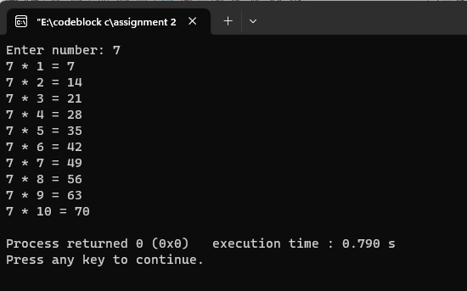

1. **Copy one variable to another variable**

#include<stdio.h>

int main()

{

int n,x=5,num,y;

n=6;

num=n;

n=x;

printf("%d\n",num);

printf("%d\n",n);

}

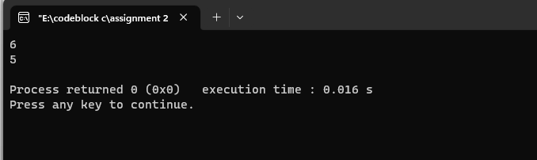

1. **Value is positive or negative or even or odd**

#include<stdio.h>

int main()

{

int n;

printf("Enter a number: ");

scanf("%d",&n);

if(n>=0 && n%2==0){

printf("The number is positive and even");

}

else if(n<0 && n%2==0){

printf("The number is negative and even");

}

else if(n>=0 && n%2!=0){

printf("The number is positive and odd");

}

else{

printf("The number is negative and odd");

}

}

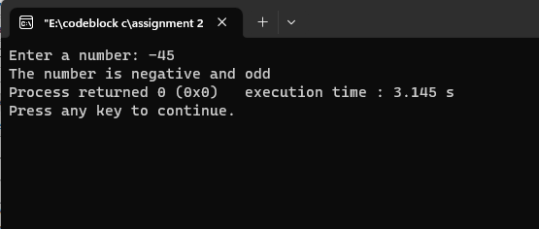

1. **Octal to decimal**

#include<stdio.h>

int main()

{

int n;

printf("Enter the octal number: ");

scanf("%o",&n);

printf("The decimal number is: %d",n);

return 0;

}

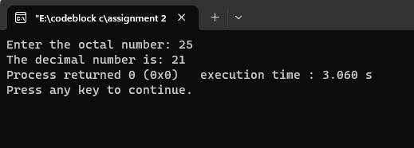

1. **Octal to hexadecimal**

#include<stdio.h>

int main()

{

int n;

printf("Enter the octal number: ");

scanf("%o",&n);

printf("The hexadecimal number is: %x",n);

return 0;

}

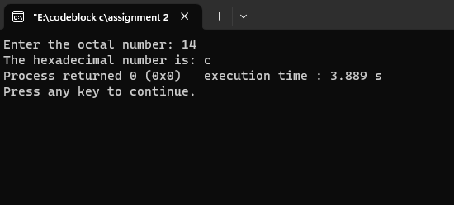

1. **Palindrome number or not**

#include<stdio.h>

int main()

{

int n,num,r,sum=0;

printf("Enter a number: ");

scanf("%d",&num);

n=num;

while(n!=0)

{

r=n%10;

sum=sum*10+r;

n=n/10;

}

if(sum==num)

printf("This is a Palindrome number");

else

printf("Not a palimdrome number");

return 0;

}

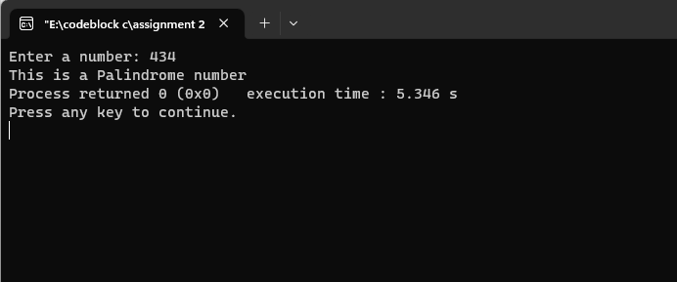

1. **Palindrome number using String**

#include<stdio.h>

int main()

{

char b[100],a[100];

printf("Enter String A :");

gets(a);

strcpy(b,a);

if(b==(strrev(a)))

{

printf("String is palindrome");

}

else

printf("The string is not palindrome");

}

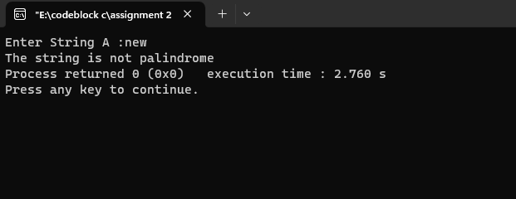

1. **Password 1234**

#include<stdio.h>

int main()

{

int pass;

printf("Enter your password: ");

scanf("%d",&pass);

if(pass==1234)

{

printf("Correct password");

}

else

{

printf("Incorrect Password");

}

return 0;

}

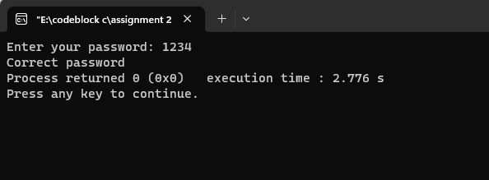

1. **Loan from a company**

#define MAXLOAN 50000

main()

{

long int loan1,loan2,loan3,sancloan,sum23;

printf("Enter the value of previous two loans: \n");

scanf("%ld %ld",&loan1,&loan2);

printf("\nEnter the value of new loan\n");

scanf("%ld",&loan3);

sum23=loan2+loan3;

sancloan = (loan1>0)?0:((sum23>MAXLOAN)?MAXLOAN-loan2:loan3);

printf("\n\n");

printf("The privious loan pending = \n%ld %ld\n",loan1,loan2);

printf("Loan requested = %ld\n",loan3);

printf("loan sanctioned = %ld",sancloan);

}

